EXPERIMENT 6
Aim : To study templates in C++
Theory: Templates are powerful features of C++ which allows you to write generic programs. In simple terms, you can create a single function or a class to work with different data types using templates.
Templates are often used in larger codebase for the purpose of code reusability and flexibility of the programs.
The concept of templates can be used in two different ways:
- Function Templates
- Class Templates

Function Templates
- A function template works in a similar to a normal function, with one key difference.
- A single function template can work with different data types at once but, a single normal function can only work with one set of data types.
- Normally, if you need to perform identical operations on two or more types of data, you use function overloading to create two functions with the required function declaration.
- However, a better approach would be to use function templates because you can perform the same task writing less and maintainable code.

Class Templates
- Like function templates, you can also create class templates for generic class operations.
- Sometimes, you need a class implementation that is same for all classes, only the data types used are different.
- Normally, you would need to create a different class for each data type OR create different member variables and functions within a single class.
- This will unnecessarily bloat your code base and will be hard to maintain, as a change is one class/function should be performed on all classes/functions.
- However, class templates make it easy to reuse the same code for all data types.

Write a C++ program to implement a function template to swap two elements

#include<iostream>
using namespace std;
template<class T>
void swap1(T &a,T &b)
{
a = b-a;
b = b-a;
a = a+b;
}
int main()
{
int a,b;
cout<<"Enter two int numbers"<<endl;
cin>>a>>b;
cout<<"a: "<<a<<" b: "<<b<<endl;
swap1(a,b);
cout<<"After swapping"<<endl;
cout<<"a: "<<a<<" b: "<<b<<endl;

float x,y;
cout<<"Enter two floats"<<endl;
cin>>x>>y;
cout<<"a: "<<x<<" b: "<<y<<endl;
swap1(x,y);
cout<<"After swapping"<<endl;
cout<<"a: "<<x<<" b: "<<y<<endl;

char c1,c2;
cout<<"Enter two characters"<<endl;
cin>>c1>>c2;
cout<<"a: "<<c1<<" b: "<<c2<<endl;
swap1(c1,c2);
cout<<"After swapping"<<endl;
cout<<"a: "<<c1<<" b: "<<c2<<endl;

double d1,d2;
cout<<"Enter two doubles"<<endl;
cin>>d1>>d2;
cout<<"a: "<<d1<<" b: "<<d2<<endl;
swap1(d1,d2);
cout<<"After swapping"<<endl;
cout<<"a: "<<d1<<" b: "<<d2<<endl;

}

OUTPUT:

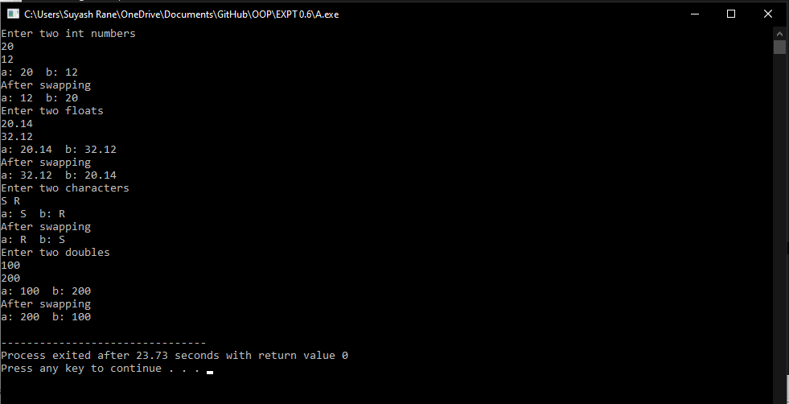

Write a C++ program to create a class template to represent a generic vector. Include the member functions to perform the following tasks
- Create the vector
- To modify the value of a given element
- To display the vector elements
#include<iostream>
#include<iomanip>
using namespace std;
template<class T>
class vector{
int n;
T *array;
public:
vector()
{
n=0;
array=NULL;
}
vector(int n)
{
this->n = n;
array = new T[n];
}

friend istream& operator>>(istream &a,vector &v)
{

for(int i=0;i<v.n;i++)
{
a>>v.array[i];
}
return a;
}

friend ostream& operator<<(ostream &a,vector &v)

{

for(int i=0;i<v.n;i++)
{
a<<v.array[i]<<setw(5);
}

return a;
}
void modify()
{
int pos,c;
T num,ele;
cout<<"1- Modify by position"<<endl;
cout<<"2- Modify by value"<<endl;
cin>>c;
switch(c){
case 1:
cout<<endl<<"Enter the pos where u want to change the element"<<endl;
cin>>pos;
if(pos>=n)
{
cout<<"Not possible"<<endl;
return;
}
cout<<"Enter new element"<<endl;
cin>>num;
array[pos-1]=num;
break;
case 2:
cout<<endl<<"Enter the element to be changed"<<endl;
cin>>ele;
cout<<"Enter new element"<<endl;
cin>>num;
for(int i=0;i<n;i++)
{
if(array[i]==ele)
{
array[i]=num;
break;

}
}

}
}

};

int main()
{

int n;
cout<<"Enter size"<<endl;
cin>>n;
vector<int> v = vector<int>(n);

cout<<"Enter integer Elements\n";
cin>>v;
cout<<"Int Vector : ";
cout<<v<<endl;
v.modify();
cout<<"After Modification: ";
cout<<v<<endl;
vector<char> vc = vector<char>(n);

cout<<"Enter char Elements\n";
cin>>vc;
cout<<"Char Vector : ";
cout<<vc<<endl;;
vc.modify();
cout<<"After Modification: ";
cout<<vc;
}
OUTPUT:

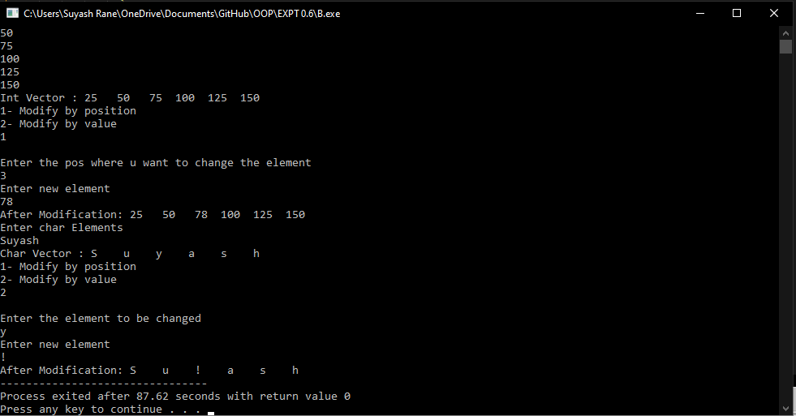

CONCLUSION:
- Templates remove code duplication.
- Like normal parameters, we can pass more than one data types as arguments to templates.
- Like normal parameters, we can specify default arguments to templates. The following example demonstrates the same.
- Both function overloading and templates are examples of polymorphism feature of OOP.
- We can pass non-type arguments to templates. Non-type parameters are mainly used for specifying max or min values or any other constant value for a particular instance of a template. The important thing to note about non-type parameters is, they must be const.

